Quantum Generative Adversarial Networks (Quantum GANs & Hybrid GANs)

1. Problem
Generative modeling aims to learn the underlying probability distribution of data in order to generate new, realistic samples. Classical Generative Adversarial Networks (GANs) achieve this using two competing neural networks: a generator and a discriminator.
Quantum Generative Adversarial Networks (QGANs) extend this concept by using quantum circuits to represent either the generator, the discriminator, or both, with the goal of exploiting quantum probability distributions and sampling capabilities.

2. Intuition
A Quantum GAN follows the same adversarial idea as a classical GAN:
- A Generator tries to produce samples resembling real data
- A Discriminator tries to distinguish real data from generated data
- Both models improve through adversarial training
In quantum GANs: - The generator may be a parameterized quantum circuit producing quantum samples - The discriminator may be classical or quantum - Training occurs in a hybrid quantum–classical loop

3. Model / Circuit Structure
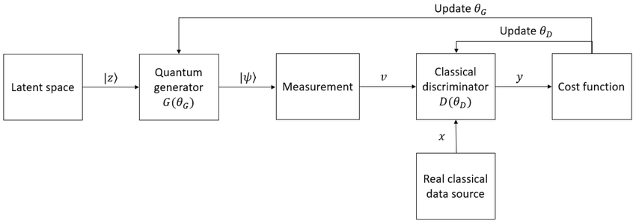
Quantum GANs come in different variants:
- Quantum Generator + Classical Discriminator (Hybrid GAN)
Most practical and commonly implemented.
- Quantum Generator + Quantum Discriminator
Fully quantum but experimentally challenging.
- Classical Generator + Quantum Discriminator
Less common, mainly theoretical.
High-level flow:
[ z G_{} x_{} D_{} {0,1} ]

4. Simple Math Involved
- Generator distribution: [ x = G_(z) ]
- Discriminator output: [ D_(x) ]
- Adversarial objective: [ G D ; {x p{}}[D(x)] + _{z p(z)}[(1 - D(G(z)))] ]
Quantum circuits parameterize either (G) or (D).

5. Python Code (Quantum GAN – Algorithm)
Platform-agnostic, Qiskit-based hybrid QGAN implementation
import numpy as np
from qiskit import QuantumCircuit
from qiskit.circuit.library import RealAmplitudes
from qiskit.primitives import Sampler
num_qubits = 2
generator = QuantumCircuit(num_qubits)
ansatz = RealAmplitudes(num_qubits, reps=2)
generator.compose(ansatz, inplace=True)
generator.measure_all()
sampler = Sampler()
def discriminator(x, w):
return 1 / (1 + np.exp(-np.dot(w, x)))
w = np.random.randn(2)
theta = np.random.rand(len(ansatz.parameters))
for step in range(10):
job = sampler.run(generator, shots=256)
result = job.result()
samples = list(result.quasi_dists[0].keys())
fake_data = np.array([list(map(int, format(s, '02b'))) for s in samples])
grad = fake_data.mean(axis=0) - 0.5
w += 0.1 * grad
print("Training complete (conceptual QGAN).")
This code demonstrates a hybrid Quantum GAN where the generator is quantum and the discriminator is classical.

6. Where the Algorithm Is Useful
- Generative modeling
- Quantum data generation
- Studying quantum probability distributions
- Benchmarking quantum advantage in sampling

7. Limitations
- Training is unstable (like classical GANs)
- Limited scalability on current hardware
- No proven quantum advantage yet
- Fully quantum GANs are experimentally difficult

8. Comparison with Classical GANs
- Generator: Classical neural network vs. quantum circuit
- Sampling: Classical pseudo-random vs. quantum measurement
- Training: Both rely on adversarial optimization
- Maturity: Classical GANs are mature; QGANs are experimental

9. One-Sentence Summary
Quantum GANs extend adversarial learning by using quantum circuits as generators and/or discriminators to model complex probability distributions.

